**NAME : SHAIK IMRAN**

**REGISTER NO : 192210567**

**SLOT : B**

**SUBJECT CODE : CSA1581**

**SUBJECT NAME : CLOUD COMPUTING AND BIG**

**DATA ANALYTICS FOR**

**NETWORK VISUALIZATION**

**EXERCISE 1**

Create a simple cloud software application and provide it as a service using any Cloud Service Provider to demonstrate Software as a Service (SaaS)

**DATE :**

**AIM:** To create and deploy a simple cloud software application as a service using a cloud service provider to demonstrate Software as a Service (SaaS).

**OUTPUT STEPS AND IMPLEMENTAION**

**STEP 1**

Opening Zogo .com



**STEP 2**

Login to the zogo.com

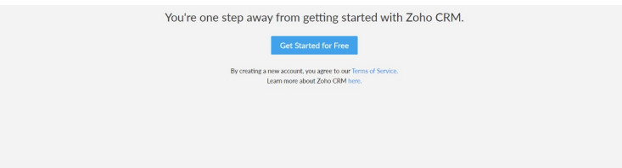

**STEP 3**

Selected one application

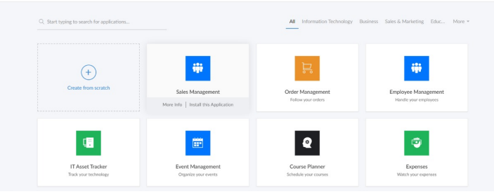

**STEP 4**

Entered the application name

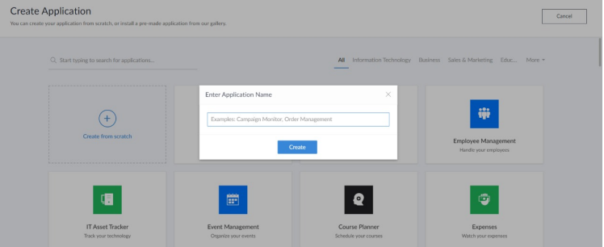

**STEP 5**

Crated new application

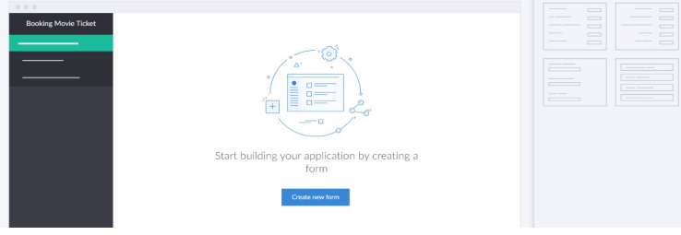

**STEP 6**

Select one form

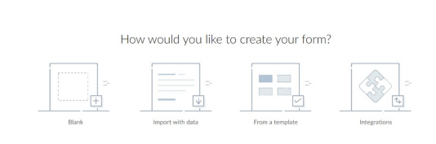

**STEP 7**

The software has been created

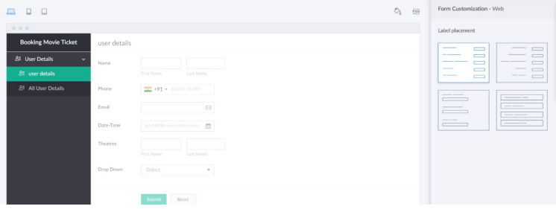

**EXERCISE 2**

Create a Virtual Machine with 1 vCPU, 2GB RAM and 15GB storage disk using a Type 2 Virtualization Software

**DATE :**

**AIM:** To create a virtual machine with specific hardware specifications using Type 2 Virtualization software

**OUTPUT STEPS AND IMPLEMENTAION**

**STEP 1**

DOWLOADED VMWARE WORKSTATION AND INSTALLED AS TYPE 2 HYPERVISOR

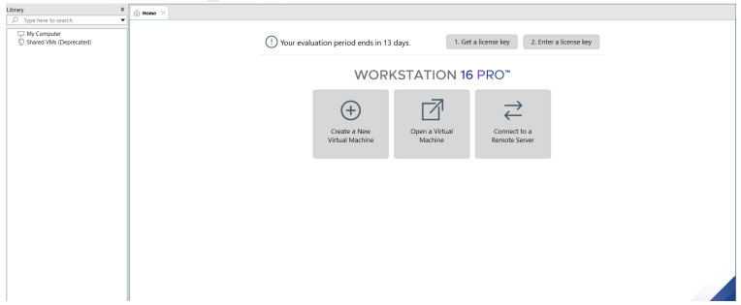

**STEP 2**

DOWLOADED UBUNTU

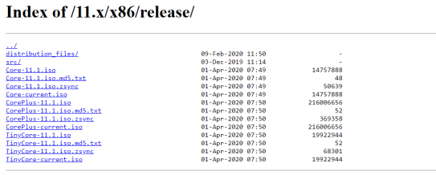

**STEP 3**

Created new VM ware workstation

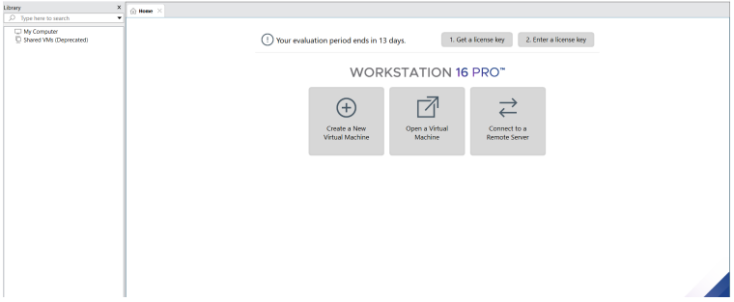

**STEP 4**

**Basic configuration settings were done**

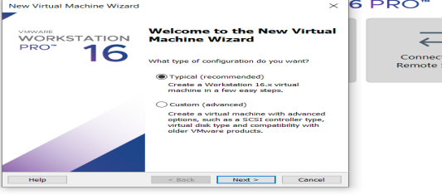

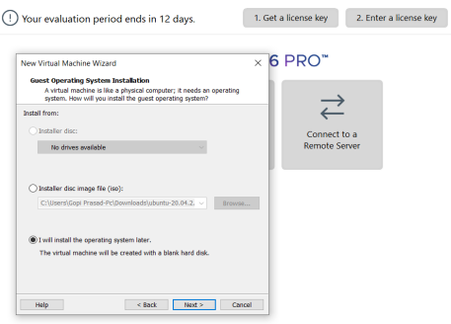

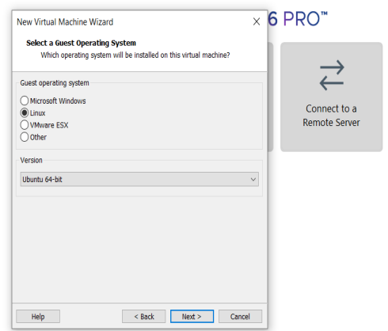

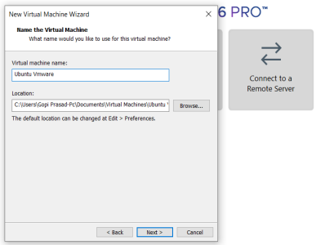

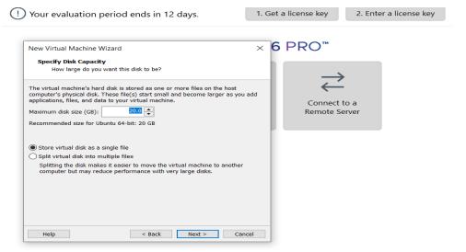

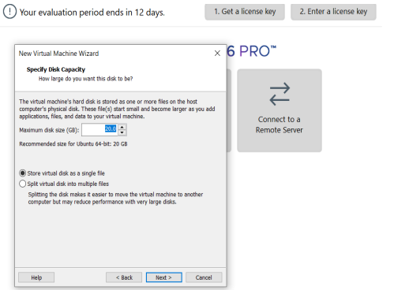

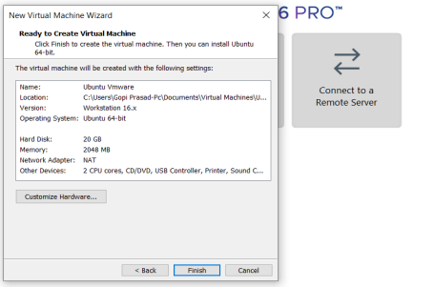

**STEP 5**

Created OS Vertual machine

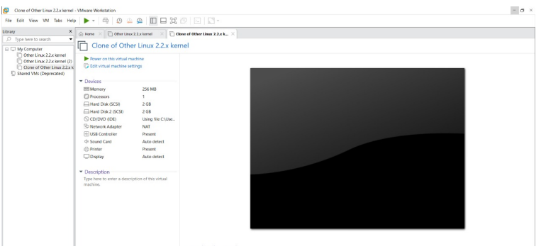

**STEP 6**

Lunched the VM

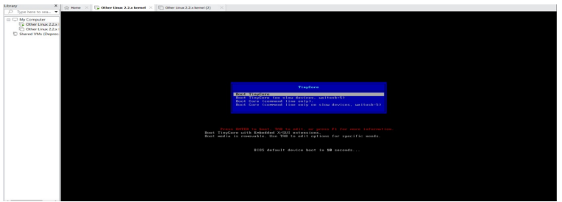

**EXERCISE 3**

CREATE A VIRTUAL HARD DISK AND ALLOCATE THE STORAGE USING VM WARE WORKSTATION

**DATE :**

**AIM:** To create a Virtual Hard Disk and allocate storage using VMWare Workstation.

**OUTPUT STEPS AND IMPLEMENTAION**

**STEP 1**